Friendship House

484 Southchurch Road

Southend-on-sea

SS1 2QA
E: volunteers@southend.foodbank.org.uk
T: 07456426203

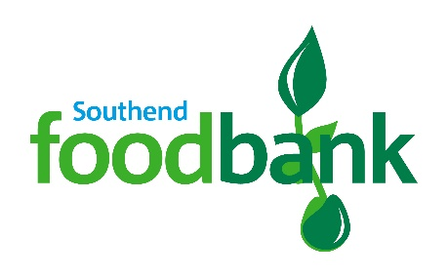

Volunteer Application Form

Thank you for your offer to help with Southend foodbank. In order for us to process your application, please would you answer the following questions:
(If you have any questions about your application or would like help completing it, please contact volunteers@southend.foodbank.org.uk

Title:
Full Name:
Address:

Postcode:
Tel No:
Email:
Date of Birth:

I would be interested in helping in the following area(s):
- Delivery or Collections (using own vehicle)
- Foodbank distribution centre (see times they are open below)
- One off events
- Warehouse

Day open | Location | Times | Tick if interested
Monday | Ferndale Baptist Church, North Avenue, Southend, SS2 5HU | 12.30-3.30pm
Monday | Faith, Hope and Charity Shop, 39 Hedingham Place, Rochford SS4 1UP | 4.30-6:45pm
Tuesday | Belle Vue Baptist Church, Belle Vue Avenue, Southend, SS1 2QZ | 12.30-3.30pm
Wednesday | Eastwood Baptist Church, Rayleigh Road, Eastwood, SS9 5PY | 9:00-11.30am
Wednesday | St Saviours Church, Kings Road, Westcliff, SS0 8LL | 1.30-3.30pm
Thursday | Shoeburyness and Thorpe Bay Baptist Church, 90 Thorpdene Gardens, Shoeburyness, SS3 9JD | 12:30-2:30pm
Friday | Earls Hall Baptist Church, 120 Hobleythick Lane, Westcliff-on-sea, SS0 0RJ | 12:00-3:00pm
Saturday | West Leigh Baptist Church, 1150 London Road, Leigh-on-sea, SS9 2AJ | 9:00-11.30am

Do you have a clean driving licence? (not necessary for all roles) Yes No

Do you have any health issues, care or support needs or disabilities that we should be aware of? Yes No

If yes, please give details:

Please tell us your previous work experience or qualifications:

Safeguarding
The following questions are in line with our commitment to safer recruitment and ensuring we have sufficient support in place for volunteers. Please note having unspent convictions etc would not necessarily prevent you from volunteering. Additional information may be required if the role is eligible for a DBS/PVG / Access NI check.

Do you have any criminal unspent charges or convictions (under the Rehabilitation of Offenders Act 1974)? (NB: this does not necessarily prevent you from volunteering)
Yes No
If yes, please give details:

Has your name been placed on a list of people barred from working with children or vulnerable adults?
Yes No

Are you currently under investigation by the police?
Yes No
Emergency Contact

Name:

Telephone number:

Relationship:

Please give us any information you think may be useful to us:

Data protection: I confirm that the above information is complete and correct. I consent to the processing of this data in the consideration of my application and during the course of my volunteering, where applicable.
Signature: Date:
Applicants must be 18 or over to volunteer at the foodbank.
Please return completed form to: volunteers@southend.foodbank.org.uk

